COP 4710-RVD
Homework 1 Spring 2022

Due date: January 27, 2022 (Thursday), 11:59 pm (EST)

Submission Instructions: Please submit answers to this assignment through the Canvas system in PDF/Word Doc format before the deadline.

Problems:

- Explain the following terms:
  - Database
- A database is a collection of data that is organized and can be accessed electronically. This is done either by storing to a local machine if the database is small or on the cloud if the database is large. Databases are usually used for accessing, storing, and maintaining data. Files that a database may contain are things such as customer data, transactions, and financial information. Furthermore, an example of someone using a database are businesses. The data that is stored can contain information of sales and other information’s that are from a customer or patient which can be useful to track and improve the business or customer experience.
  - Database Management System (DBMS)
- Database Management System or DBMS for short is a software package that is meant to facilitate a database through the creation and maintenance of said database. This happens by the software package which is designed to manipulate the data in a database either by retrieving or managing the data that is in a database. The DBMS can generally manipulate the data format along with the field names, record structures and file structures.
  - Database System
- A database system is the database management system software paired with the data itself. When it comes too DBMS there are several types Hierarchical, Network, Relational, object-oriented, graph, ER model, Document, NoSQL.

- What is the difference between controlled and uncontrolled redundancy?
- The difference between controlled and uncontrolled redundancy is that the redundancy is controlled when the DBMS can ensure that the same data has multiple copies that are consistent. While if the DBMS has no control over ensuring that the data has multiple copies that are consistent then it will be an uncontrolled redundancy.

- Discuss different categories of data models.
- There are three different categories of data models. The three are Conceptual, Physical, Implementation. Conceptual (high-level, semantic) provides concepts which are very similar to how many users perceive data. This can also be called entity-based or object-based data models. Physical (low-level, internal) provides concepts that detail how the data is stored on a computer. Implementation (record-oriented) provide concepts deals with both of the ones which were mentioned above by balancing the user views and providing computer storage details.

- Discuss Logical Data Independence and Physical Data Independence.
- Logical Data Independence has the capacity to change the conceptual schema without the need of having to change external schemas and their application programs. Physical Data Independence however has the capacity to change internal schema without having to change the conceptual schema.

- Describe the three-schema architecture. Why do we need mapping between schema levels? How does different schema definition language support this architecture?
- The three-schema architecture are internal level, conceptual and external. The internal is used to define the data which is stored in a block. The conceptual describes the whole structure of the database this includes the relationships among the data and the implementation of said data. External level can be represented as a different view of the database in which it describes the database the user is interested and hides the rest of the database.

- We need mapping because of the external schemas, and the need to view the data in a particular way. Since the data is stored in the internal schema we would need to extract and utilize the data from the internal schemas to the external schemas. This would mean that maps connecting the three schemas will need to be created and constructed.

- Different schema definition languages support this architecture by for example older DBMS will include physical level details in the conceptual schema. Another example is Oracle, SQL Server where external schema concepts can be found in the same place as the conceptual schema’s concepts.
- Consider Figure 1.2.

FIGURE 1.2 A database that stores student and course information.
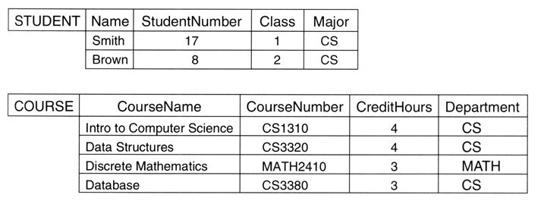
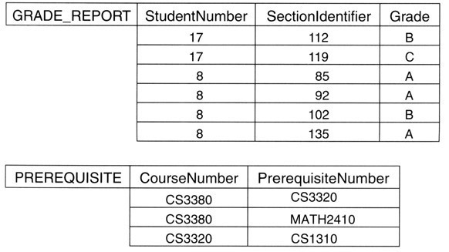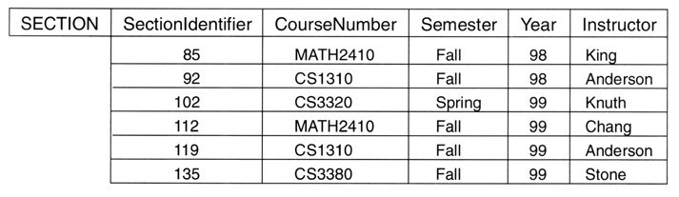

a). If the name of the CS (Computer Science) Department changes to CSSE (Computer Science and Software Engineering) Department and the corresponding prefix for the course number also changes, identify the columns in the database that would need to be updated. You should answer this question using the following example.

Example:

Answer Below-
Table | Column(s)
STUDENT | Major
COURSE | CourseNumber and Department
SECTION | CourseNumber
PREREQUISITE | CourseNumber and PrerequisiteNumber

b). Can you restructure the columns in COURSE, SECTION, and PREREQUISITE tables so that only one column will need to be updated? You should answer this question using the following example.

Example:
Answer Below -

Table | Column | Split Columns
COURSE | CourseNumber | CourseDept and CourseNum
SECTION | CourseNumber | CourseDept and CourseNum
PREREQUISITE | CourseNumber | CourseDept and CourseNum
PREREQUISITE | PrerequisiteNumber | PreReqDept and PreReqNum

